**Format to report your ADVANCED JAVA PROGRAMMING PROJECTS**

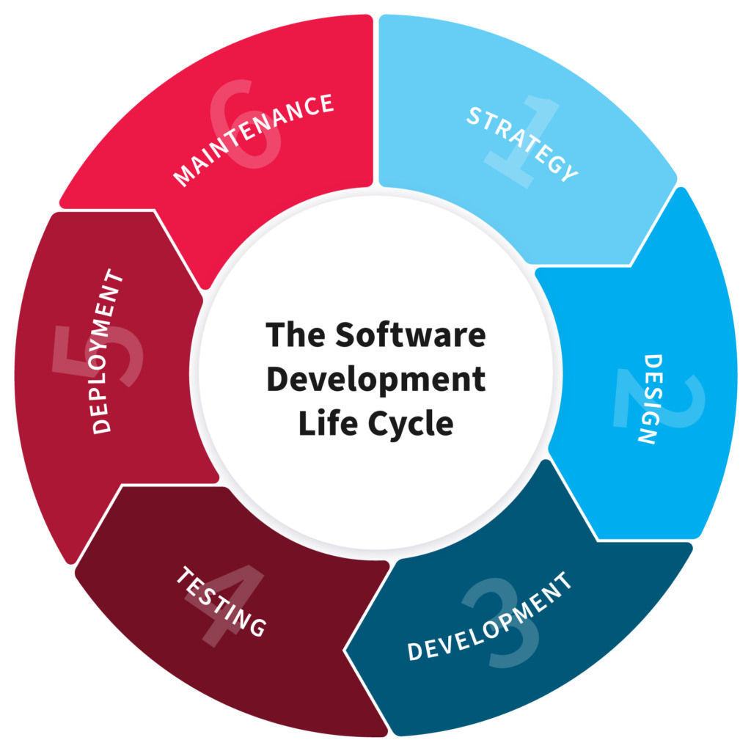

**NAME: UMURERWA MIREILLE**

**REG NO: 220013685**

**CLASS NO: Group 2**

**PROJECT NAME:**